OAuth2 Server Design Document
Version 1.0
April 11, 2015

Document Information
Category | Information
Customer
Project | OpenHMIS
Document
Document Version | 1.1
Identifier
Author(s) | Ashaar Riaz
Approver(s)
Issue Date | April 11, 2015
Document Location
Distribution
Document Revision History
Author | Date | Version | Description(Change made, Sec Ref, CR#)
Ashaar Riaz | April 11, 2015 | 1.0 | Oauth2 Server Design Document
Ashaar Riaz | April 26, 2015 | 1.1 | REST Web Service Component, HMIS Business Component

Definition of Terms, Acronyms and Abbreviations
This section should provide the definitions of all terms, acronyms, and abbreviations required to interpret these terms properly. This information may be provided by reference to the project Glossary.
Term | Description
User | An entity who is interacting with the HMIS System.
HMIS Server | HMIS Server implements Oauth2 API
External Application | Any application trying to access the Oauth2 Server.

List of Appendices
Appendix # | Appendix Name | Page #

Goal
The objective of this document is to describe the OAuth2 Server detail design.
Assumptions
We have made the following technical and non-technical assumptions:
- OAuth2 Server will be implemented on the basis of some existing Open Source Oauth2 Specification Implementation software. Apache software organization provide Apace Altu for this purpose and Spring Security from the Spring Organization also provides the same kind of facility.
- We will not be implementing everything from the beginning. We will be utilizing the existing framework and implementing our business requirements.
- Oauth2 Server will be implemented as a separate project but it would be easy to integrate with the other software developed by Pathway or it would be easy to merge with the other software project codes if required.
- Database is already designed for Oauth2 server to utilize. All the tables where the token and it’s user information is stored.
- Token will be generated for 3600 second or one hour as the other Oath Server does. System should be capable of updating the token time as required.
- Token time or time to live token will be saved in a property file. System will dynamically read this value from the property file.
- Oauth2 Server will used the same parameters as in the Oauth2 Specification. In other words we can add new parameters if required but the standard will be covered always.
Target Audience
This document is written for the following different types of roles or stake holder in the system.

Software Engineer
All those people who will be involved in the programming or writing the code.

Quality Assurance Engineer
All those people who will be testing this software.

Project Manager
All those people who will be managing this software development.

Ouath2 Server
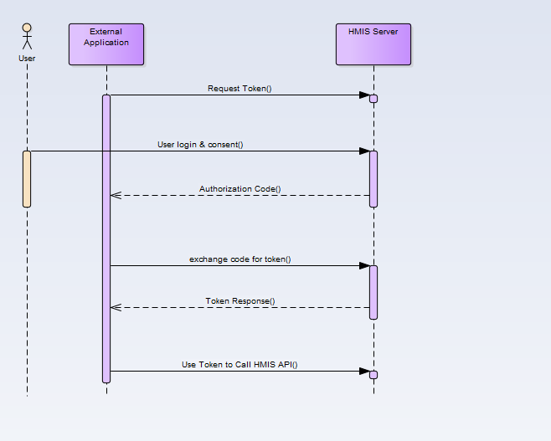
Fig.1 Time line diagram of Oauth2 Server

External application will make a login and consent request. First the request token will be generated based on the supplied parameters. System will then exchange the code with the exteranal application and after successful exchange, token will be generated.
Once the token will be generated exteranl application will be able to call the HMIS-API.

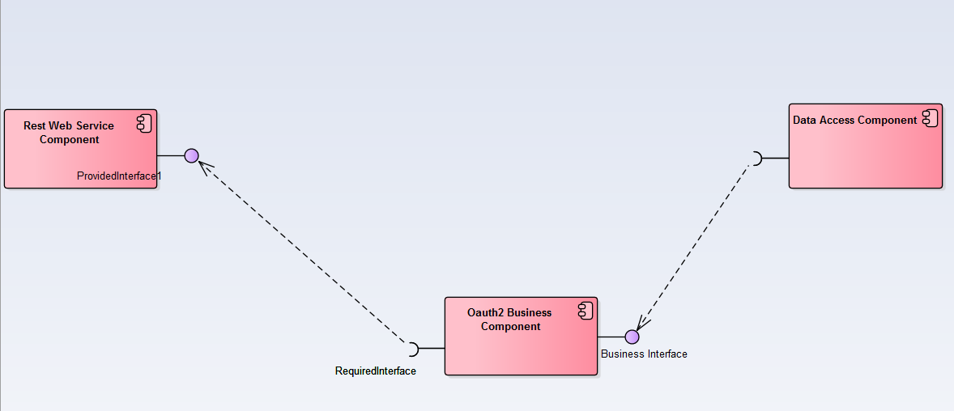
Fig2. Component Diagram
Component diagram of the Oauth2 Server. It consist of three component, Rest Web Service Component, Oauth2 Business component and back end Data Access component.
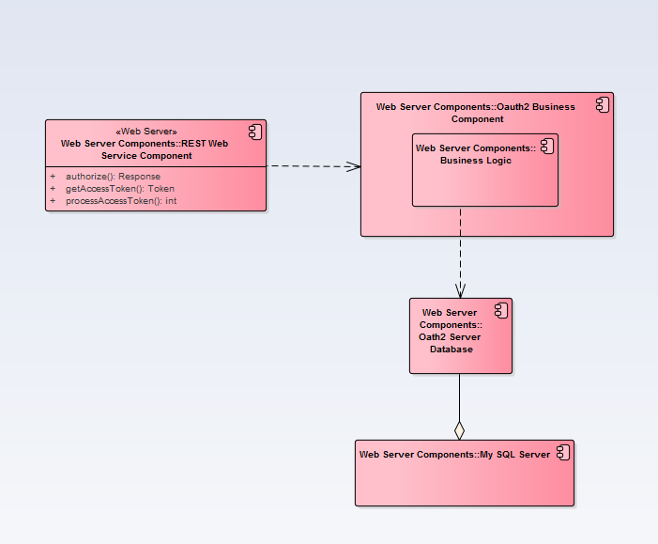
Fig. Detail Component Diagram

Rest Web Service Component
This is the first point of interaction to the external application. We will be implementing the REST API in this component. Following are three classes in this component as explained in detail in the class diagram section.
- AbastractEndPoint
- AuthorizationEndPoint
- TokenEndPoint

Oauth2 Business component
This component will contains all the business logic of the Oauth2.
Following are the classes in this component
- AuthorizationServiceImpl
- AuthorizationService
- TokenServiceImpl
- TokenService

Data access Component
This component will handle all the database operation. For example save a token into the database and retrieving an existing user’s token from the database.
Following are the classes in this component
- AuthorizationDAOImpl
- AuthorizationDAO
- TokenDAOImpl
- TokenDAO

Request Token Use Case
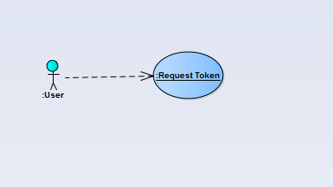
Fig. Request Token Use Case Diagram
This use case is about requesting a new token in the system. An external application will make this request. Token along with the user information will be saved in the database.
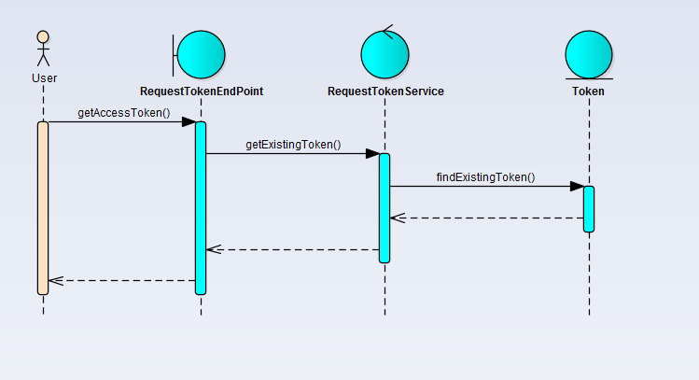

Exchange Code Use Case
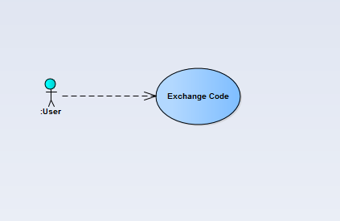
Fig. Exchange Code Use Case Diagram
This use case is about the exchange of the code between the external application and HMIS Server. A Token will only be generated after the successful exchange of the code.
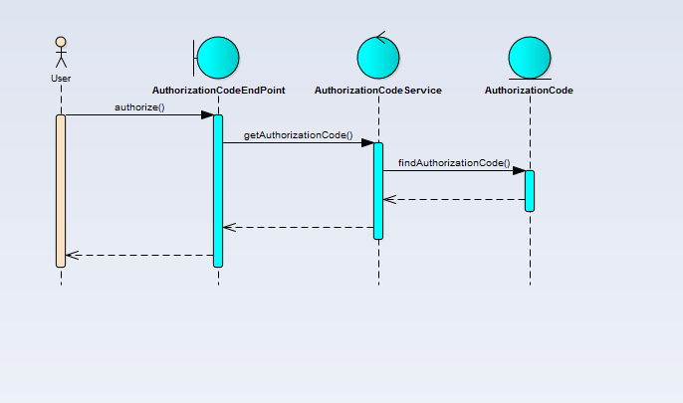
Fig. Exchange Code Use Case Diagram

Class Diagram

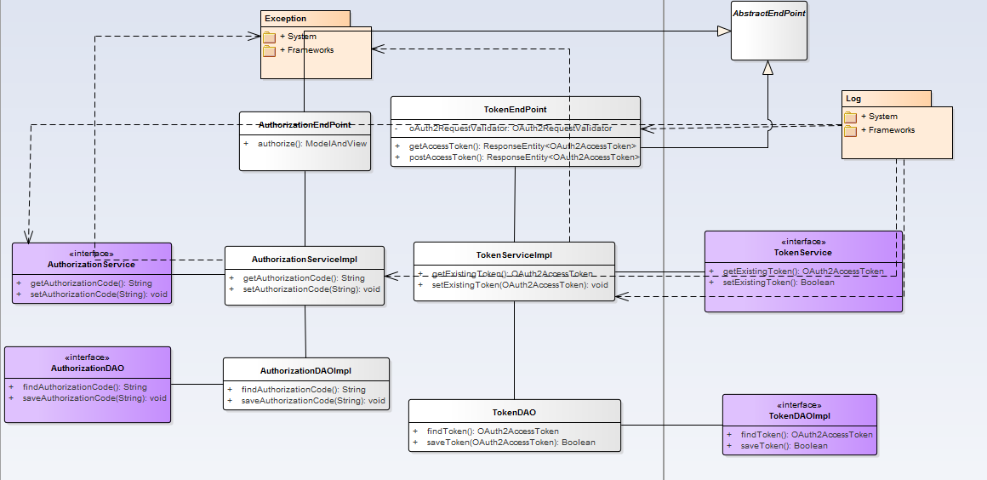
AbstractEndPoint
This class contains the common method for both AuthorizationEndPoint and TokenEndPoint class.
AuthorizationEndPoint
This class handles all the functionality of the authorization code. User will requests an authorization code using http://server:port/servletcontext/oauth/code REST API request.
- Server is the name of the system where the oatuh2 server is running. If you are deploying on the local machine it would be localhost
- Port is the port number where the application is running. By default tomcat server is running on port 8080
- Server context of the application running on the tomcat.
TokenEndPoint
This class handles all the functionality of accessing and saving token. User will make a token request using http://server:port/servletcontext/oauth/token REST API request.
AuthorizationServiceImpl
Service Class to handle the authorization code.
AuthorizationService
Interface for the AuthorizationServiceImpl class.
AuthorizationDAOImpl
Data Access object to handle the authorization code.
Authorization
Interface for the AuthorizationDAOImpl
TokenServiceImpl
Service class to handle the code.
TokenService
Interface to TokenServiceImpl
TokenDAOImpl
DataAcces Object to handle the token.
TokenDAO
Inteface to TokenDAOImpl

Framework
Spring Security and Spring Framework 4.x.x will be used for the implementation.

